ASSIGNMENT BOOKLET 1A

- Nation and Identity
- Shaping Nationalism

SENIOR HIGH SCHOOL
Fort Saskatchewan 780 992 0101
Sherwood Park 780 464 1899
Vegreville 780 632 7998

Assignment Booklet Questions Rubric 10-1/20-1/30-1

 | Excellent (5) | Proficient (4) | Satisfactory (3) | Limited (2) | Poor (1)
Communication  Consider effectiveness of student’s:  - organization  - Syntax, mechanics, and grammar  - Use of vocabulary and Social Studies terminology | Writing is fluent and skillfully structured. Controlling idea effectively sustained and integrated. Skillfully controlled. Absence of error impressive. Precise, deliberate vocabulary. | Writing is clear and purposefully structured. Controlling idea coherently sustained and integrated. Capable control. Minor errors do not impede communication. Appropriate, specific vocabulary. | Writing is straightforward and functionally ordered. Controlling idea generally maintained. Basic control. Occasional lapses and minor errors, however generally clear. Conventional, adequate vocabulary. | Writing is awkward and lacks clarity. Controlling idea inconsistently maintained. Faltering control. Errors obscure the clarity of communication. Imprecise, simplistic vocabulary. | Writing is unclear and disorganized. Controlling idea is absent. Lack of control. Jarring errors impede communicationOvergeneralizedinaccurate vocabulary.
Interpretation & Analysis of Responses:  Consider how effectively the students critically analyze and demonstrate an understanding of the question | Insightful and sophisticated analysis and understanding of question. Perceptive, and comprehensively developed response. | Sound and adept analysis and understanding of question. Purposeful and capably developed response. | Straightforward and conventional analysis and understanding of question. Generalized and adequately developed response. | Analysis and understanding of question incomplete, lacks depth. Response is superficial and lacks development. | Minimal analysis and understanding of the question. Disjointed and vague response.

**IMPORTANT: Students are expected to complete ALL OF THE QUESTIONS in the assignment booklets. Booklets with less than 85% complete will be returned to the student for completion. **

Social Studies 20-1 Assignment Booklet 1

Watch: Samurai, Daimyo, Matthew Perry, and Nationalism: Crash Course World History #34

Chapter 1: Nation and Identity
_______________________________________________________

1. (Page 1) Exploring Nationalism

In Social Studies we often use the phrase “to what extent.” This means that the question being answered requires us to form an opinion using a spectrum.

For example, make an X on the spectrum-lines below to answer the questions below.

a) How much do you like pizza?

.___________________________________________________________________.
little bit lots

b) How important to you is it to keep your bedroom tidy, clean and organized?

.____________________________________________________________________.
not so much extremely important

c) To what extent should teenagers have curfews?

.____________________________________________________________________.
never always

2. a) What is the single key issue that this textbook is built around?

b) Today, how would you answer the question you have just written above?

c) Before you can address this issue, what must you first do?

d) Why are there various ways to define nationalism?

3. (Page 1) Nationalism: The Word

a) (Figure P-1) List six words that use “nation” as their root word.

b) A prefix comes at the __________________ of a word, and a suffix comes at the

____________________ of a word.

c) When you see the suffix “-ism,” you know that you are looking at a _____________.

This suffix often signals that the noun in question refers to an ____________________

___________________________________.

d) An ideology is:

For example:

4. (Page 2) Points of View* and Perspectives* on Nationalism

Define “point of view”

Define “perspective”

a) The word ____________________ did not even exist in _____________________

until the middle of the _____________________ _____________________.

b)

- Some believe that the concepts of ____________________ and

____________________ have existed for as ____________________________

________________________________________________________________

- Some argue that these ideas [of nation and nationalism] are rooted in early

societies such as _____________________ and _____________________

or _____________________.

- Some argue that the current ideas about nationalism began in the

____________________ with the American and ____________________

Revolutions.

5. (Page 2) Definitions of Nationalism (Blue sidebar)

Oxford Canadian Dictionary Keywords

d) George Orwell: “Nationalism is inseparable from the

e) Adrian Hastings: When do the feelings of nationalism chiefly arise?

When nationalism becomes “stoked up,” then what happens?

5. (Page 3) Your Exploration of Nationalism

What is the Key Issue for the entire Social Studies 20-1 course?

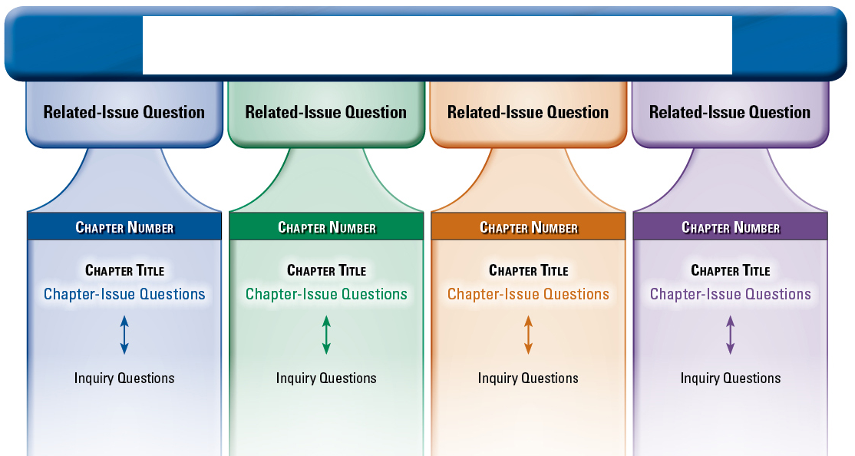

6. (Page 4) What is an Issue?

a) An issue is:

b) What is a dilemma?

7. (Page 14) Related Issue 1 - WRITE DOWN THE 4 MAIN TOPICS

a.

b.

c.

d.

8. (Page 15) Photograph, Bottom left, Four RCMP Officers

a) What seems to be the attitudes of the four RCMP officers?

b) What is the central issue that this photograph is dealing with?

c) What are three possible positions a person could take on the issue that you have written in question (b) above?

d) In this photograph, look at the RCMP officer on the far left. What do you think are the most important parts of his personal identity?

9. (Page 19) Key Terms

Using the glossary that starts on page 388, write out the definitions for the following key terms.

nation-state

international

patriotism

ethnic

self-determination

sovereignty

civic nationalism

ethnic nation

10. Read pages 20-21.

a) When people talk about “nation” what are three different things they may often mean?

b) What does “nation” mean to you? In the space below, jot down 5-10 words that describe your understanding of “nation.”

c) In 3 to 5 complete sentences, explain whether or not your concept of nation involves something that you can physically see or touch.

11. (Page 20, Figures 1-2 and 1-3, Page 24) Nation as a Patriotic Concept

a) In your opinion, is it important to express patriotism by participating in Remembrance Day activities? Explain your ideas in 5-7 complete sentences.

b) To be patriotic, is it necessary to support everything your nation does? Explain why or why not.

12. (Page 24) One Expression of Patriotism

a) Respond to the following question: “Would you die for your country?” Give reasons for your position.

13. (Page 25) What are some understandings of nation?

a) What does Peter Russell believe about the term “nation”?

b) Explain whether or not you agree with Peter Russell, and why.

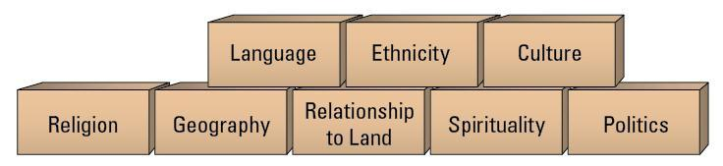

14. (Page 25) Linguistic Understandings of Nation

a) Read this section, and answer the following question.

Why do you suppose Harper chose to call Québécois [that is, the people who live in Québec] a nation, but NOT call the province of Québec a nation?

b) (Page 26) Ethnic Understandings of Nation
What are some advantages and disadvantages of basing a nation on a common ethnicity?
c) (Page 26) Cultural Understandings of Nation
Culture is:
How are the images in Figures 1-7 and 1-8 related to cultural understandings of nation?

d) (Page 27) Religious Understandings of Nation

The textbook explains some information about Judaism, which is the religion that
Jewish people follow. List three other major religions that are not listed in the textbook.

You are welcome to ask other people, look in books, or check the internet.

e) (Page 27) Geographic Understandings of Nation

What are three geographical features that isolate people?

What happens to people and groups who are isolated by geography?

Examine the map of Tibet in Figure 1-11. What physical features isolated the people of

the Tibetan Plateau?

How might this isolation have influenced the Tibetans’ collective identity as expressed through their languages, culture, religion, and forms of government?

f) (Page 28) Nation and Relationship to Land

Explain what is meant by “Spirit of Place.” Give examples, from either your own life, the textbook, or observations of how “Place” can be important to individuals or groups of people.

g) (Page 28) Spiritual Understandings of Nation

Give three examples of how a people’s relationship with the land is sometimes bound up with spiritual connections.

h) (Page 29) Political Understandings Nation

Read the section on politics. What does Aiken believe about the Chinese takeover of
Tibet?

Do you consider Tibet to be a nation? Explain

Is Tibet sovereign, yes or no? Explain your response.

(Page 29, continued) The Dene Nation wanted to have self-determination. Using their declaration and the glossary to help you, explain what the Dene Nation was asking for, and explain whether or not you think they should get what they wanted.

15. (Page 30) How can a nation be understood as a civic concept?

a) Turn to page 21 and read the Voices comments made by Charles Hanley. Is Canada a civic nation? Explain why you either agree or disagree with Hanley.

b) (Page 30) Shared Values and Beliefs Expressed in Law

The phrase “rule of law” is important because

[Laws] express the values and beliefs that Canadians choose to embrace and _
c) Below is an excerpt from Canada’s constitution. List four items that you personally find very important.
Legal Rights (7-14)
7. Everyone has the right to life, liberty and security of the person and the
right not to be deprived thereof except in accordance with the principles of
fundamental justice.
8. Everyone has the right to be secure against unreasonable search or seizure.
9. Everyone has the right not to be arbitrarily detained or imprisoned.
10. Everyone has the right on arrest or detention
(a) to be informed promptly of the reasons therefor;
(b) to retain and instruct counsel without delay and to be informed of
that right; and
(c) to have the validity of the detention determined by way of habeas
corpus and to be released if the detention is not lawful.
11. Any persons charged with an offence has the right
(a) to be informed without unreasonable delay of the specific offence;
(b) to be tried within a reasonable time;
(c) not to be compelled to be a witness in proceedings against that
person in respect of the offence;
(d) to be presumed innocent until proven guilty according to law in a
fair and public hearing by an independent and impartial tribunal;
(e) not to be denied reasonable bail without just cause;
(f) except in the case of an offence under military law tried before a
military tribunal, to the benefit of trial by jury where the maximum
punishment for the offence is imprisonment for five years or a more
severe punishment;
(g) not to be found guilty on account of any act or omission unless, at
the time of the act or omission, it constituted an offence under Canadian
or international law or was criminal according to the general principles of
law recognized by the community of nations;
(h) if finally acquitted of the offence, not to be tried for it again and, if
finally found guilty and punished for the offence, not to be tried or
punished for it again; and
(i) if found guilty of the offence and if the punishment for the offence
has been varied between the time of commission and the time of
sentencing, to the benefit of the lesser punishment.
12. Everyone has the right not to be subjected to any cruel and unusual
treatment or punishment.
13. A witness who testifies in any proceedings has the right not to have any
incriminating evidence so given used to incriminate that witness in any other
proceedings, except in a prosecution for perjury or for the giving of
contradictory evidence.
14. A party or witness in any proceedings who does not understand or
speak the language in which the proceedings are conducted or who is deaf
has the right to the assistance of an interpreter.

`

16. (Page 31) The Making of a Civic Nation

a) “Civic” refers to

b) “Civic government” refers to

c) One understanding of the concept of civic nation combines two key elements:

d) A civic nation emerges from the

e) Do you agree with Ibbitson’s portrayal of Canada as a civic nation? Explain your response.

18. (Page 32) Nation and Nation State

a) One understanding of the term “civic nationalism” suggests that:

b) Using the glossary to help you, explain what is necessary for Britain to be considered a nation-state.

b) In several sentences, explore your opinion on the following statement:
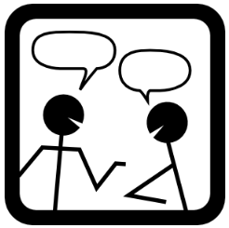

Alberta is a very wealthy province. It has all it needs to become its own nation-state. Perhaps it is time for Albertans to start thinking about Alberta becoming its own country.

19. (Page 37) How do people express their identity through nation?
a) How strong people feel about their “National Identity” is different for each person.

Place an X on the spectrum below that shows to what extent do YOU feel a strong connection to your national identity?

.____________________________________________________________________.
Very strong connection Very weak connection

b) (Page 36 continued) William Bloom wrote that people have internalized the symbols of nation, and that they internalize these symbols.

In point form, list some of the Canadian “symbols” that we have internalized that would unite Canadians as a group. (Hint: think of animals, or flag, or sports)

20. (Page 37) The Evolution of National Identity

a) On the spectrum below, mark an X to show your opinion to the following question:

To what degree to you feel a connection to your identity as a Canadian?

.____________________________________________________________________.
Very little Lots

b) According to comments in this section, what are two different ways that a nation can develop and come into being?

21. (Page 37) How is a nation part of who you are?

Choose one of the three speakers from this section, and summarize their ideas.

22. (Pages 38-41) Myths and National Identity

Read these pages, and then in point form, list ten facts and examples about how myths affect national identity.

Chapter 2: Shaping Nationalism
_______________________________________________________

23. (Page 43) Shaping Nationalism

a) What is the central issue for chapter 2?

b) Use the glossary to define the following Key Terms.

collective consciousness

rhetoric

24. (Page 44-45) What are some factors that shape nationalism?

Watch: What Was the Enlightenment? AP Euro Bit by Bit #25
Watch: French Revolution in 9 Minutes - Manny Man Does History

a) Read all of pages 44 and 45. What are some reasons that the people of France revolted against Louis XV?

VIEW:
The French Revolution Notes
Download File

b) In what ways does the French Revolution have an important role in shaping France’s sense of nationhood? Give examples to support your ideas.

25. (Page 45) France as the Centre of New Ideas and A Growing Middle Class

Read these two sections. Create a web diagram with the words “People’s New Sense of the French Nation” at the center. Link the various social factors that helped shape new ideas about the French Revolution. Under each factor, write one or two points explaining its role. Use the space below, or use a separate piece of paper.

26. (Page 47) Some Economic Factors that Shaped the French Nationalism

Economics is the study of deciding how to spend money. How did Louis the XVI abuse his economic power?

27. (Page 48) The Estates General

a) The three social groups in the Estates General were:

First Estate:

Second Estate:
___________________

Third Estate:

b) What was the goal of the Tennis Court Oath?

28. (Page 50) Some Geographic Factors that Shaped French Nationalism and
Famine Feeds Rumour

a) In the box below, explain four geographic factors that contributed to French Nationalism.

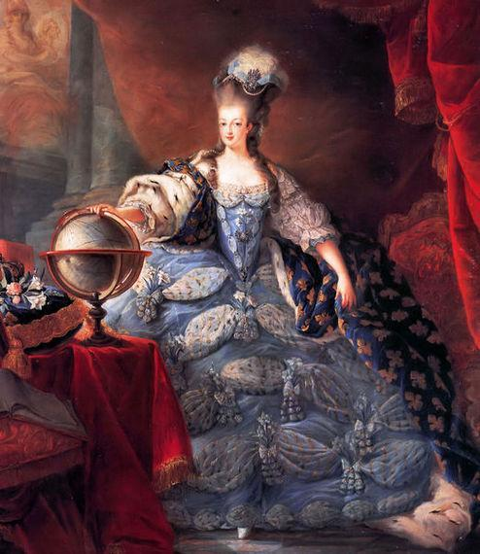
b) What is the famous line that was rumoured to
have been said by Marie Antoinette?

29. (Page 52) Some Political Factors That Shaped French Nationalism

Choose one of the items from the Declaration of the Rights of Man and of Citizen
in Figure 2-9, and explain how this new rule contrasted with the way that France used to be during the traditional reign of the kings.

30. (Page 52 Reaction outside France

What kinds of reactions were other nations’ leaders having when they observed the issues and events in France?

As a person living today, what kind of reaction do you have to the issues and events that were happening in France? How are your own reactions different or similar to those of the nations’ leaders at the time of the French Revolution?

31. (Page 53) The Revolution Becomes Extreme

Short Research Project: use online sources to research the Reign of Terror.

Find at least TWO images, place them in the space below. Write captions for each picture, explaining the events of the Reign of Terror.

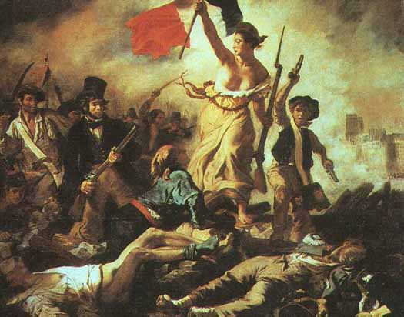

Watch the French Revolution Video and answer the corresponding questions while you view it.

French Revolution Video
1. What would the new republic be born in?

2. What would the French Revolution bring to the poor?
3. What was Robespierre called?

4. What was Robespierre's weapon?

5. How many miles is Versailles from Paris?

6. How old was Louis Capet on the eve of his wedding?

7. What are some of the words used to describe Louis?

8. Where was Louis's bride from?

9. How old was Marie Antoinette at her wedding?

10. What has the neglect of the French monarchy left the French people?

11. What is growing bigger every day?

12. How does Louis XV die?

13. How old was Louis when he became king?

14. What "above all" did Rousseau, Voltaire champion?

15. How much French money did Louis give the American Revolution?

16. What was Marie obsessed with?

17. What is the job of the queen?

18. How many children to Louis and Marie have?

19. How much bread did the average person eat per day?

20. How much did a loaf of bread soon cost?

21. What do Robespierre and the third estate demand from the First and Second Estates?

22. How many of the king's troops had moved into Paris by July?

23. What colors are in the "tri-color"?

24. What did they do with the head of the governor of the Bastille?

25. What does Louis XVI write in his diary on July 14, the day of the Storming of the
Bastille?

26. What do they do to the Bastille after the people's victory?

27. Who was not mentioned in the Declaration of the Rights of Man?

28. What is the Marat answer to the people who are against the revolution?

29. What were the women protesting about on October 5?

30. What did Marie Antoinette supposedly say when she heard about the women protesting?

31. How many people were camped outside the palace by morning?

32. Who did the people storming the palace want to get?

33. When they leave Versailles with the royal carriage, how many people are there? What had the people done with the king's guards?

35. What type of government does France now have?

36. Where do the king and queen get caught when they try to escape?

37. What does Robespierre rail against?

38. What is the nickname of the guillotine?

39. Who does the Assembly want to declare war against?
40. Who else joined in the invasion against France?

43. What does Marat want the people to do to the political prisoners?

44. How many people were killed during the September Massacres?

45. What is the usual penalty for treason?

46. What does Louis trust that his death will be for?

47. How many heads did Marat now want to fall?

48. What did Charlotte Cordae hope to achieve by murdering Marat?

49. How old is Marie Antoinette when she is placed on trial?

50. What is the final charge at Marie's trial?

51. What sentence did Marie Antoinette receive?

52. How was Marie taken to the guillotine?

53. How did the Committee of Public Safety rule France, as a collective what?

54. Who did they have to stamp out the power of?

55. How many days were in a week on the revolutionary calendar?

56. Who is the brilliant new commander of the French army?

57. What is the new type of government Robespierre wants to start?

58. How many executions were happening per month in Paris during the "Great Terror"?

59. What is the name of the festival that Robespierre celebrated forming a new religion?

60. What happened to Robespierre when he tried to commit suicide?

61. What day was Robespierre executed?

62. What is the question raised by the French revolution?

63. What are the three words that the French Revolution stood for?

32. (Page 53) WATCH: The Rise of Napoleon and (Pages 54-55) The Disastrous Campaign

Historically, people have had a hard time deciding if Napoleon was a good guy, or a bad guy. View John Green’s video (linked in the title above) and with the information learned in the video and on p.53, fill in the chart below to summarize the two conflicting opinions about Napoleon’s reputation.

Napoleon’s Reputation
Good Guy | Bad Guy

33. (Page 59) How have people in Canada responded to some factors that shape nationalism? , (Page 59) Defining Canada’s Stories, and (Page 60) Challenging Canadian Myths
a) Canadian myths tend to glorify some event or person, but ignore an ugly side of Canadian history. How does the completion of the Canadian Pacific Railway qualify as entering into a category of myth?

b) In Voices, E. Pauline Johnson’s poem has an ironic bitter twist to it. Explain how her understanding of Canada as a nation includes a careful look at the myth of the creation of Canada.
34. (Pages 61-63) Choose one of the three blue headings:
→First Nations and Metis Nationalism or
→Inuit Perspectives on Nationalism or
→Quebec Nationalism
Read the section that you choose, then create a chart or a bubble-map diagram that explains different goals that this people group has been hoping to achieve, and the challenges/obstacles that they have been trying to overcome.
Goals:

~~~End of Formative 1~~~
Submit this module and complete module 1B

